A PROJECT REPORT

ON

**Advanced Safety Technologies in Automobile Sector**

Submitted by

Under the Guidance of

**DEPARTMENT OF ELECTRONICS & TELECOMMUNICATION ENGINEERING**

**Academic Year**

**C E R T I F I C A T E**

This is to certify that have satisfactorily completed the project work entitled **“Advanced Safety Technologies in Automobile Sector”** in partial fulfillment for award of **Bachelor of Engineering** Degree in **Electronics and Telecommunication Engineering** by

### 

**DEPARTMENT OF ELECTRONICS & TELECOMMUNICATION ENGINEERING**

**C E R T I F I C A T E**

This is to certify that, the project entitled “**Advanced Safety Technologies in Automobile Sector**” is presented before departmental research committee (DRC) by, under the guidance of Prof. for the academic year 2018- 2019.

The DRC has approved the said project.

## (On company letter head with Ref. No. and Date)

To,

The Head,

Department of Eectronics and Telecommunication Engineering, Dr. J. J. Magdum College of Engineering,

JAYSINGPUR – 416 101

Sub.: - Sponsorship for B.E. Electronics and Telecommunication student’s project

regarding…..

Dear Sir,

The B.E. Electronics and Telecommunication student’s project entitled “Advanced Safety Technologies in Automobile Sector” of your department under taken by following students

Sr. No. Roll No. Name of Student

under the guidance of Prof. T. H. Mohite has been fully sponsored by our company. The problems given for the project work is <Define problem> and the expected out-comes are,

1.

2.

3.

We request you to please consider our industrial problem as a project work of

U. G. student and provide us the solution. The necessary aid required for completion of project work will be provided from our side.

Thanking you

Yours truly, (Name and signature of authorized person with seal)

*Acknowledgement*

First of all I would like to thank Prof. T. H. Mohite who is presently working as a professor of Electronics and Telecommunication department, Dr. J. J. Magdum College of Engineering, Jaysingpur guiding us through this project work. We are extremely grateful to her for all her invaluable guidance and kind suggestions during all the phases of our project work. Her ever encouraging attitude, guidance and whole hearted help were biggest motivation for us in completing this project work.

We are thankful to the Chairman Mr. Veejhay J. Magdum of Dr. J. J. Magdum Trust, Jaysingpur, for their encouragement. We are very grateful to Dr. D. N. Mudgal, Principal of Dr. J. J. Magdum College of Engineering, Jaysingpur for motivating us for this project work. Also we are thankful to Prof. T. H. Mohite, Head, Department of Electronics and Telecommunication Engineering for providing necessary facilities for completion of this project work.

We are also thankful to Miss. Pooja mam for supporting us in completion of this project work.

Lastly we thank all the persons who have guided and helped us directly or indirectly.

|  |  |  |
| --- | --- | --- |
| **Roll.No.** | **Name** | **Sign** |
| 1 |  |  |
| 2 |  |  |
| 3 |  |  |

*Contents*

|  |  |  |
| --- | --- | --- |
| **Ch. No.** | **Topic** | **Page No.** |
|  | *Acknowledgement* | *5* |
|  | *Content* | *6* |
|  | *Abstract* | *7* |
|  | *List of Figures* | *8* |
|  | *List of Symbols* | *9* |
|  | *List of Abbreviations* | *10* |
| **Chapter 1** | **INTRODUCTION** | **11 - 13** |
| 1.1 | Introduction | 11 |
| 1.2 | Objectives of project | 13 |
| **Chapter 2** | **LITERATURE REVIEW** | **14 - 15** |
| 2.1 | Introduction |  |
| 2.2 | Brief history |  |
| **Chapter 3** | **METHODOLOGY** | **16 - 54** |
| 3.1 | Function block diagram | 16 |
| 3.2 | Proteus Design | 17 |
| 3.3 | Power supply | 18 |
| 3.4 | Microcontroller 89s52 | 19-26 |
| 3.5 | Buzzer | 26-27 |
| 3.6 | Eye Blink Sensor | 27-28 |
| 3.7 | Alcohol Sensor | 28-29 |
| 3.8 | Ultrasonic Sensor | 29-31 |
| 3.9 | GPS | 31-32 |
| 3.10 | GSM | 32-38 |
| 3.11 | LCD | 38-39 |
| 3.12 | Flowchart | 40 |
| 3.13 | Program | 41-53 |
| 3.14 | Photo Of Program | 53 |
| 3.15 | Output | 54 |
| **Chapter 4** | **CONCLUSIONS & FUTURE SCOPE** | **55** |
| **Chapter 5** | ***REFERENCES*** | 56 |

# Abstract

The purpose of this project was to evaluate the educational level of the WPI community on automobile safety devices and develop an interactive medium through which visitors can establish a better understanding of the technology. An interactive video presentation and museum exhibit were constructed together to educate the community on the criteria of history, purpose, and functionality for several major automotive technologies. The presentation component incorporated pictures, videos, and diagrams to portray the educational material about each technology, while the actual exhibit includes physical components from each category to aide in visualization of these devices. This project produced positive feedback from various members of the community as well as several recommendations for future renditions of this project.

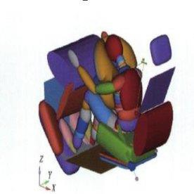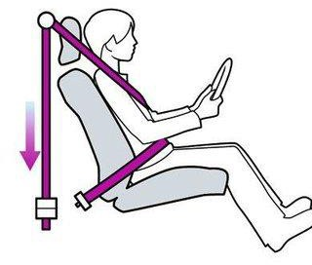

# List of Figures

|  |  |  |
| --- | --- | --- |
| **Figure No.** | **Title of Figure** | **Page No.** |
| Figure 3.1 | Block Diagram | 16 |
| Figure 3.2 | Proteus Design | 17 |
| Figure 3.3 | Power supply | 18 |
| Figure 3.4.1 | AT 89S52 Microcontroller | 19 |
| Figure 3.3.4.3 | Pin Diagram | 20 |
| Figure 3.5 | Buzzer | 27 |
| Figure 3.6 | Eye Blink Sensor | 27-28 |
| Figure 3.7 | Alcohol sensor | 28-29 |
| Figure 3.8 | Ultrasonic sensor | 29-30 |
| Figure 3.9 | GPS | 31 |
| Figure 3.10 | GSM | 33-34 |
| Figure 3.11 | LCD Display | 39 |
| Figure 3.12 | Flowchart | 40 |
| Figure 3.14 | Photo of Project | 53 |
| Figure 3.15 | Output Reading | 54 |

Symbols

**Symbol Description of Symbol**

*f0* frequency

λ0 wavelength

ε dielectric constant

ε*reff* effective dielectric constant

L length of the patch

L*eff* effective length of the patch

ΔL increased length

Lg ground dimension

W width of the patch

Wg ground dimension

h height of the substrate

# Abbreviations

|  |  |
| --- | --- |
| **Abbreviations** | **Description of Abbreviations** |
| MCLR | Master clear |
| AN | Analog channel |
| Vref | Voltage reference |
| RD | Read |
| WR | Write |
| VDD | Positive supply voltage |
| VSS | Ground |
| OSC | Oscillator |
| CLK | Clock |
| RX | Receiver |
| TX | Transmitter |
| GSM | Global system for mobile communication |
| GPS | Global positioning system |
| LCD | Liquid crystal display |

Chapter 1

# Introduction

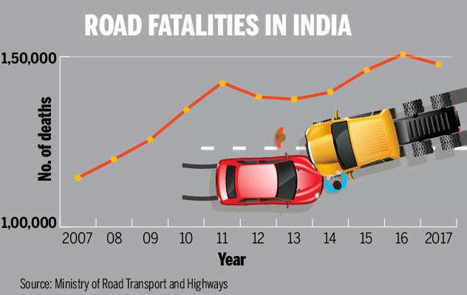



Vehicle Safety Technology (VST) in the [automotive industry](https://en.wikipedia.org/wiki/Automotive_industry) refers to [the special](https://en.wikipedia.org/wiki/Advanced_driver-assistance_systems) [technology](https://en.wikipedia.org/wiki/Advanced_driver-assistance_systems) developed to ensure the safety and security of automobiles and their passengers. The term encompasses a broad umbrella of projects and devices within the automotive world. Notable examples of VST include geo-fencing capabilities, remote speed sensing, theft deterrence, damage mitigation, vehicle-to-vehicle communication, and car-to-computer communication devices which use [GPS tracking.](https://en.wikipedia.org/wiki/GPS_tracking_unit)



VST were first implemented in the 20th century, when they were introduced by the automobile industry in response to legislators’ efforts to reduce the number of road accidents. Early examples of VST included safety glass, four-wheel hydraulic brakes, seat belts, and padded dashboards. In 1934, General Motors began a scientific approach to vehicle safety by conducting the first [crash barrier test](https://en.wikipedia.org/wiki/Crash_test). Gradually, existing systems were stabilized, followed by the introduction of disc brakes and anti-lock braking systems. High-tech safety systems were first introduced in 1995 with Electronic Stability Control (ESC). Lane departure warning systems were introduced in the year 1999, and radar assisted adaptive cruise control was introduced in 2005. However, these technologies are not standard inclusions in all vehicles.

To prevent or account for drowsiness while driving, many companies have researched technologies to either detect drowsiness and protect the driver or keep the driver awake. One

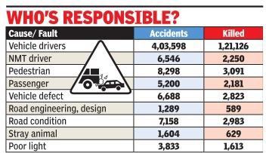technology that aims to keep drivers awake is blue light. Blue light strains the eyes, making it difficult to fall asleep while driving, and it may be contained in all interior lights, touchscreens, clocks, and lights illuminating the speedometer and gas meter. Another preventative technology, designed to detect drowsiness, works by using data from lane departure sensors to identify jerky movements or swerving in and out of lanes. Once received, a coffee symbol on the dashboard will illuminate or a verbal response will sound to alert the driver that they should take a break. The driver’s seat can also vibrate to startle them in the hopes that they become more alert.

These technologies are not yet perfect and are often faulty in detecting drowsiness. Other technologies are also being developed, including the flashing of bright lights containing blue light to keep drivers awake, along with steering technology that can correct for driver error while swerving due to drowsiness

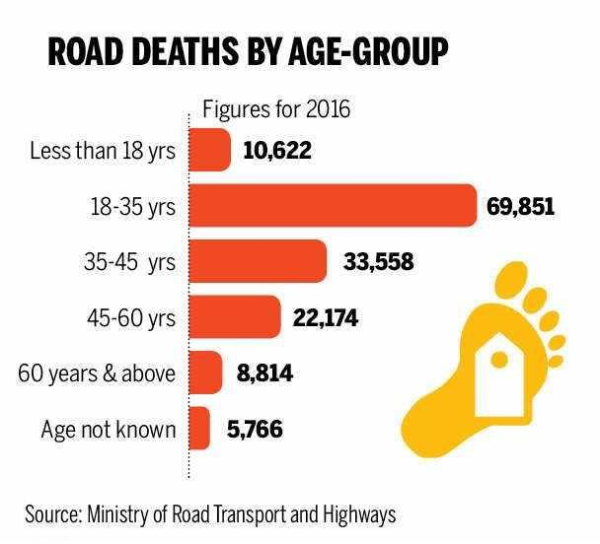

OBJECTIVE OF PROJECT:

* To design fundamental for safe traffic system which requires safe interaction between users, vehicles and the road environment.
* To take account of the behavioral and physical limitations of road users and can address a range of risk factors and help to reduce exposure to risk, crash involvement and crash injury severity.

Chapter 2

# Literature Review

#### A Survey Paper On Drowsiness Detection & Alarm System for Drivers:

The existing system consists of various approaches like image processing, EEG, vehicular , vocal measures etc. Any of these approaches doesn’t give 100% results. The maximum result is achieved using EEG based approaches but these are intrusive in nature. Other techniques also have some limitations which don’t allow them to give perfect result.

#### Alcohol Detection of Drunk Drivers:

In this paper, we proposed a method to sense the presence of alcohol from the breath of drivers and curtail the catastrophic effects it can have on peoples’ lives. The system was designed and implemented successfully via the use of Arduino no ATMEGA328 microcontroller and MQ-3 sensor. Experimental evaluation of the system showed that the alcohol sensor was able to deliver fast response when alcohol is detected. Also, the ability of the alcohol sensor to operate over a long time is a feature of the proposed system.

#### An Ultrasonic Sensor for Distance Measurement in Automotive Applications:

A low-cost distance sensor is described in this paper that is able to self-adapt to the environmental conditions. The sensor contains a noise measurement system and an auto-change facility of the signal that is used to drive the transmitter, thus producing the best accuracy under different conditions. Tests have been performed inreal driving conditions and have shown a regular 14ehavior of the sensor under all typical driving maneuvers for speeds of up to 33 m/s (120 km/h). The sensor features a simple and costless analog processing of the signal without employing microprocessors.

#### Accident Detection System:

Nowadays, to provide a suitable safety of road accident preventing and detection system is becoming one of the most important things for the future generation.

There is an increasing the death of people because of road accidents. The demand for this process is to save life just on time after the accident has occurred. There are so many ways to know the location after the accident has occurred. This GPS and GSM based automatic accident detection system is also one of the less delay time and the most effective system for this present days.

#### Pressure sensitive element with increased mechanical strength:

The utility model relates to the field of measurement technology and automatics. This model can be used in small-sized pressure-to-electrical transducers. The pressure sensitive element contains an integral pressure chip (as transducer). The chip has a front side with piezoresistors, electrical connections and contact pads. All elements are connected into a bridge circuit.

#### Estimation of the Residual Energy in Battery Electric Vehicles:

The driving range of battery electric vehicles (BEVs) has been fairly extended during recent years, as a consequence of little improvements in energy density of lithium-based batteries. Nonetheless, charging stations are not widespread installed in all geographical areas. For these reasons, range anxiety still acts as a barrier when considering to move from traditional fuel vehicles to BEVs. Most of the traditional range estimation methods are untrustworthy because they leverage upon the electric energy drawn by the motor.

Chapter 3

# Methodology

## Functional Block Diagram:

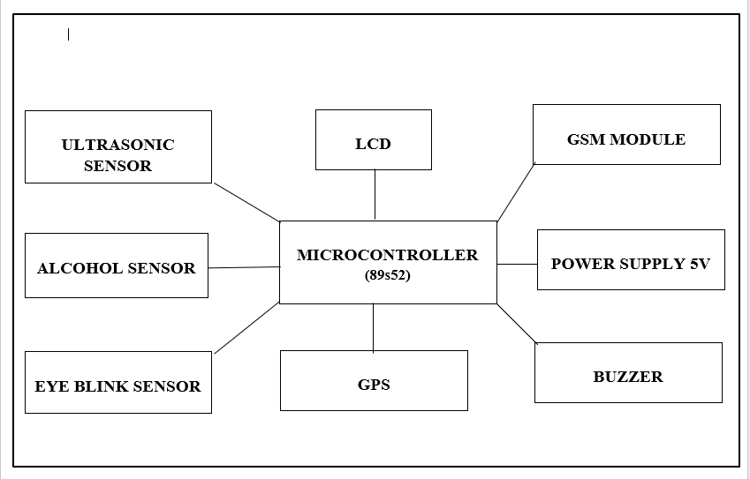

* + 1. **Block Diagram**

The block diagram include various sensors, GPS, GSM Module and Microcontroller. Transmitter section mainly consists of: the sensor circuit, the microcontroller unit, the display unit and GSM module. The sensor circuit contains the alcohol sensor, Eye Blinking sensor, Ultrasonic sensor. One sensor provides analog output, which is converted to digital form using ADC channel of the controller and another sensor provides digital output and which is further processed to get temperature, humidity. Those measured parameters will be displayed in an LCD display. Block diagram of the overall system is shown in fig. Receiver section consists of our mobile. All the coming from weather station to our mobile. In this system

central part is heart of our system. There will be the AT 89S52 microcontroller. We will be interface the different type of sensor with AT 89S52 microcontroller. We will also interface GSM & LCD with PIC microcontroller.

## Proteus Design:

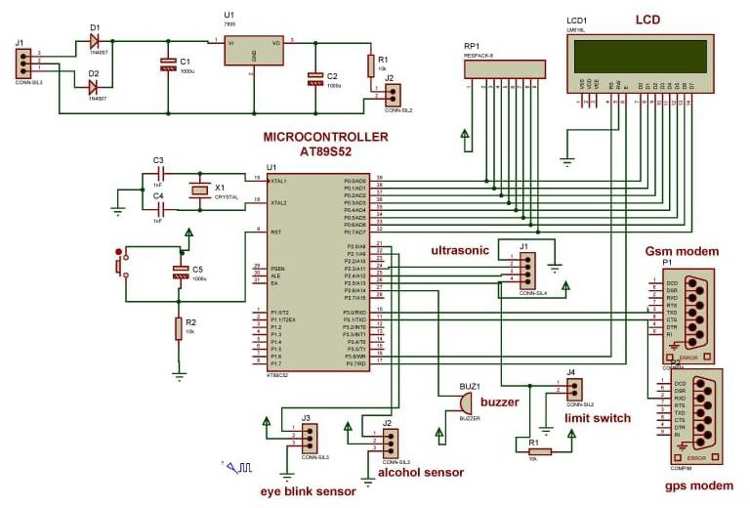

* 1. **Proteus design of power supply**

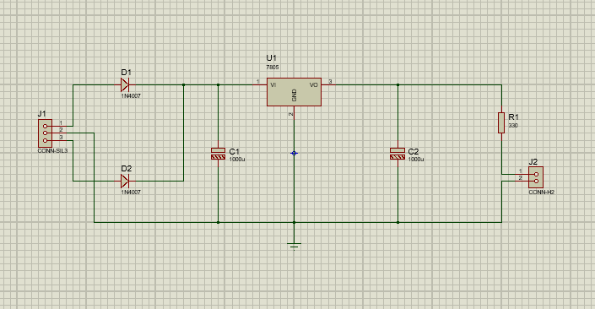

* 1. **MICROCONTROLLER AT 89S52:**

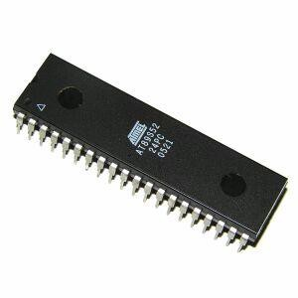The Microcontroller IC 89S52 has 256x8 bit internal RAM which is most important feature for this application. Here eight to ten readings can be recorded in RAM after each half an hour to achieve data logging. The Timer/Counter application of 89S52 is used to count the pulses from proximity sensor. The interrupt pin INTR0 is used to switch into different setting modes The serial channel is used to get interface with pc for data logger application.

**Fig. 3.4.1 AT 89S52 Microcontroller**

The AT89C52 provides the following standard features: 8Kbytes of Flash, 256 bytes of RAM, 32 I/O lines, three 16-bittimer/counters, a six-vector two-level interrupt architecture, a full duplex serial port, on-chip oscillator, and clock circuitry. In addition, the AT89C52 is designed with static logic for operation down to zero frequency and supports two software selectable power saving modes.The Idle Mode stops the CPU while allowing the RAM, timer/counters, serial port, and interrupt system to continue functioning. The Power down Mode saves the RAM contents but freezes the oscillator, disabling all other chip functions until the next hardware reset.

* + 1. **MICROCONTROLLER AT 89S52 FEATURES**
       - Compatible with MCS 51 products
       - 8k bytes of in system Re-programmable Flash Memory
       - Fully static operation : 0 Hz to 24 MHz
       - 256 x 8 bit internal RAM
       - 32 programmable I/O Lines
       - Three 16 bit Timer or Counters
       - 8 Interrupt sources
       - Programmable serial channel
       - Low power Idle & power down modes
    2. **Pin Diagram:**

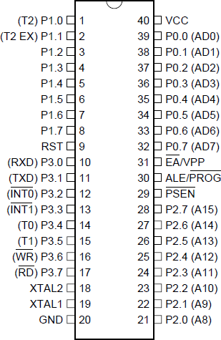

**Fig. 3.4.3.1 Pin Diagram PIC89s52**

## Pin Description:

**VCC:** Supply Voltage

**GND:** Ground

**Port 0:**

Port 0 is an 8-bit open drain bidirectional I/O port. As an output port, each pin can

sink eight TTL inputs. When 1s are written to port 0 pins, the pins can be used as high- impedance inputs.Port 0 can also be configured to be the multiplexed low-order address/data bus during accesses to external program and data memory. In this mode, P0 has internal pull-

ups.Port 0 also receives the code bytes during Flash programming and outputs the code bytes dur- ing program verification. **External pull-ups are required during program verification**.

**Port 1:**

Port 1 is an 8-bit bidirectional I/O port with internal pull-ups. The Port 1 output

buffers can sink/source four TTL inputs. When 1s are written to Port 1 pins, they are pulled high by the inter- nal pull-ups and can be used as inputs. As inputs, Port 1 pins that are externally being pulled low will source current (IIL) because of the internal pull-ups.In addition, P1.0 and P1.1 can be configured to be the timer/counter 2 external count input (P1.0/T2) and the timer/counter 2 trigger input (P1.1/T2EX), respectively, as shown in the follow- ing table. Port 1 also receives the low-order address bytes during Flash programming and verification.

|  |  |
| --- | --- |
| **Port Pin** | **Alternate Functions** |
| P1.0 | T2 (external count input to Timer/Counter 2), clock-out |
| P1.1 | T2EX (Timer/Counter 2 capture/reload trigger and direction control) |
| P1.5 | MOSI (used for In-System Programming) |
| P1.6 | MISO (used for In-System Programming) |
| P1.7 | SCK (used for In-System Programming) |

**Port 2:**

Port 2 is an 8-bit bidirectional I/O port with internal pull-ups. The Port 2 output

buffers can sink/source four TTL inputs. When 1s are written to Port 2 pins, they are pulled high by the inter- nal pull-ups and can be used as inputs. As inputs, Port 2 pins that are externally being pulled low will source current (IIL) because of the internal pull-ups.Port 2 emits the high-order address byte during fetches from external program memory and dur- ing accesses to external data memory that use 16-bit addresses (MOVX @ DPTR). In this application, Port 2 uses strong internal pull-ups when emitting 1s. During accesses to external data memory that use 8-bit addresses (MOVX @ RI), Port 2 emits the contents of the P2 Special Function Register.Port 2 also receives the high-order address bits and some control signals during Flash program- ming and verification.

**Port 3:**

Port 3 is an 8-bit bidirectional I/O port with internal pull-ups. The Port 3 output buffers can sink/source four TTL inputs. When 1s are written to Port 3 pins, they are pulled high by the inter- nal pull-ups and can be used as inputs. As inputs, Port 3 pins that are externally being pulled low will source current (IIL) because of the pull-ups.Port 3 receives some control signals for Flash programming and verification.Port 3 also serves the functions of various special features of the AT89S52, as shown in the fol- lowing table.

|  |  |
| --- | --- |
| **Port Pin** | **Alternate Functions** |
| P3.0 | RXD (serial input port) |
| P3.1 | TXD (serial output port) |
| P3.2 |  |

|  |  |
| --- | --- |
|  | INT0 (external interrupt 0) |
| P3.3 | INT1 (external interrupt 1) |
| P3.4 | T0 (timer 0 external input) |
| P3.5 | T1 (timer 1 external input) |
| P3.6 | WR (external data memory write strobe) |
| P3.7 | RD (external data memory read strobe) |

**RST:**

Reset input. A high on this pin for two machine cycles while the oscillator is running

resets the device. This pin drives high for 98 oscillator periods after the Watchdog times out. The DISRTO bit in SFR AUXR (address 8EH) can be used to disable this feature. In the default state of bit DISRTO, the RESET HIGH out feature is enabled.

**ALE/PROG:**

Address Latch Enable (ALE) is an output pulse for latching the low byte of the address during accesses to external memory. This pin is also the program pulse input ~~(PROG~~) during Flash programming.In normal operation, ALE is emitted at a constant rate of 1/6 the oscillator frequency and may be used for external timing or clocking purposes. Note, however, that one ALE pulse is skipped dur- ing each access to external data memory.If desired, ALE operation can be disabled by setting bit 0 of SFR location 8EH. With the bit set, ALE is active only during a MOVX or MOVC instruction.

**EA/VPP:**

External Access Enable. EA must be strapped to GND in order to enable the device to fetch code from external program memory locations starting at 0000H up to FFFFH. Note, however, that if lock bit 1 is programmed, EA will be internally latched on reset. EA should be strapped to VCC for internal program executions.

**XTAL1:**

This pin also receives the 12-volt programming enable voltage (VPP) during Flash programming.Input to the inverting oscillator amplifier and input to the internal clock operating circuit.

**XTAL2:**Output from the inverting oscillator amplifier.

**POWER SUPPLY:**

The system requires 5V of continuous power supply for the proper functioning for that purpose we designed the power supply which has circuitry as shown in figure 4.1.

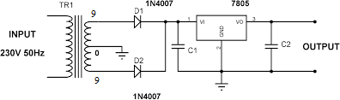

Fig. 4.1 Circuit diagram of power supply

The input ac voltage, typically 220V RMS, is connected to a transformer, which steps that ac voltage down to the level of the 9V dc output. A diode rectifier then provides a full wave rectified voltage that is initially filtered by a simply capacitor filter to provides a dc voltage. This resulting dc voltage usually has some ripple or ac voltage variation.

A regulator circuit removes the ripples and also remains the same dc value even if the input dc voltage varies, or the load connected to the output dc voltage changes. This voltage regulation is usually obtained using voltage regulator IC units. The block diagram of power supply is as shown in figure 4.1.2.



Fig. 4.2 Block diagram of power supply

**Working principle of Centre tapped transformer**

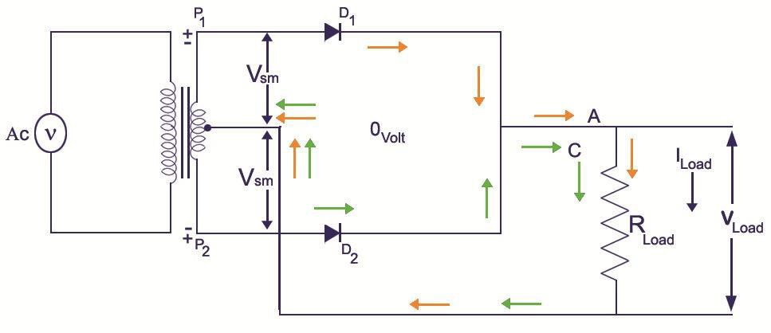A Centre Tapped transformer works in more or less the same way as a usual transformer. The difference lies in just the fact that its secondary winding is divided into two parts, so two individual voltages can be acquired across the two line ends. Centre tapped full-wave rectifier circuit is as shown in f

Fig. 4.3 Centre tapped full-wave rectifier circuit

The internal process is the same, which is when an alternating current is supplied to the primary winding of the transformer it creates a magnetic flux in the core, and when the secondary winding is brought near, an alternating magnetic flux is also induced in the secondary winding as the flux flows through the ferromagnetic iron core and changes its direction with each and every cycle of the alternating current. In this way an alternating current also flows through the two halves of the secondary winding of the transformer and flows to the external circuit.

**IC Voltage regulator**

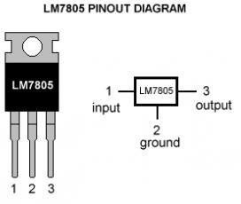

Fig.4.4 3-terminal voltage regulator

The schematic given above in figure 4.1.4 shows how to use a 7805 IC, there are 3 pins in IC 7805, pin 1 takes the input voltage and pin 3 produces the output voltage. The GND of both input and out are given to pin 2.

Voltage sources in a circuit may have fluctuations resulting in not giving fixed voltage outputs. Voltage regulator IC maintains the output voltage at a constant value. 7805, a voltage regulator integrated circuit (IC) is a member of 78xx series of fixed linear voltage regulator ICs used to maintain such fluctuations. The xx in 78xx indicates the fixed output voltage it provides. IC 7805 provides +5 volts regulated power supply with provisions to add heat sink as well.

**Voltage regulator**IC's are the IC’s that are used to regulate voltage. **IC 7805** is a **5V Voltage Regulator**that restricts the voltage output to **5V** and draws 5V regulated power supply. It comes with provision to add heat sink. The maximum value for input to the voltage regulator is 35V. If the voltage is near to 7.5V then it does not produce any heat and hence no need for heat sink. If the voltage input is more, the excess electricity is liberated as heat from 7805.

**Voltage regulator**IC's are the IC’s that are used to regulate voltage. **IC 7805** is a **5V Voltage Regulator**that restricts the voltage output to **5V** and draws 5V regulated power supply. It comes with provision to add heat sink. The maximum value for input to the voltage regulator is 35V. If the voltage is near to 7.5V then it does not produce any heat and hence no need for heat sink. If the voltage input is more, the excess electricity is liberated as heat from 7805.

IC 7805 is a series of 78XX voltage regulators. It’s a standard, from the name the last two digits 05 denotes the amount of voltage that it regulates. Hence a 7805 would regulate 5v and 7806 would regulate 6V and so on.

The series of 78XX and their output voltages are as shown in table 4.1.1.

|  |  |  |
| --- | --- | --- |
| **IC Part** | **Output Voltage** | **Minimum Vi** |
| 7805 | 5 | 7.3 |
| 7806 | 6 | 8.3 |
| 7808 | 8 | 10.5 |
| 7810 | 10 | 12.5 |
| 7812 | 12 | 14.6 |
| 7815 | 15 | 17.7 |
| 7818 | 18 | 21 |
| 7824 | 24 | 27.1 |

Table 4.1 Positive Voltage Regulator in 78XX series

## Buzzer:

A **buzzer** is a small yet efficient component to add sound features to our project/system. It is very small and compact 2-pin structure hence can be easily used on [breadboard,](https://components101.com/misc/breadboard-connections-uses-guide) Perf Board and even on PCBs which makes this a widely used component in most electronic applications.

There are two types are buzzers that are commonly available. The one shown here is a simple buzzer which when powered will make a Continuous Beeeeeeppp. sound, the other

type is called a readymade buzzer which will look bulkier than this and will produce a Beep. Beep. Beep. Sound due to the internal oscillating circuit present inside it. But, the one shown here is most widely used because it can be customised with help of other circuits to fit easily in our application.

This buzzer can be used by simply powering it using a DC power supply ranging from 4V to 9V. A simple 9V battery can also be used, but it is recommended to use a regulated

+5V or +6V DC supply. The buzzer is normally associated with a switching circuit to turn ON or turn OFF the buzzer at required time and require interval.

**Applications of Buzzer**

* Alarming Circuits, where the user has to be alarmed about something.
* Communication equipments.
* Automobile electronics.
* Portable equipments, due to its compact size.

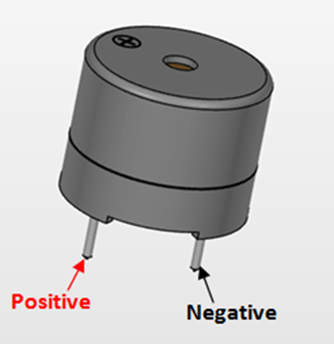

## Eye Blink Sensor Design:

We are developing one unit to avoid accident. The main function of this project is to measure eye blinking using IR sensor.

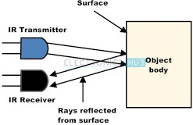

SPECIFICATION

* Connection : VCC-VCC; GND-GND; OUT-IO Using the comparator LM393, stable
* Can be used for 3-5V DC power supply modules . When the power is turned on, the red power indicator light
* Each module shipments comparing the threshold voltage has been adjusted by the potentiometer is good , not exceptional circumstances, do not arbitrarily adjust the potentiometer

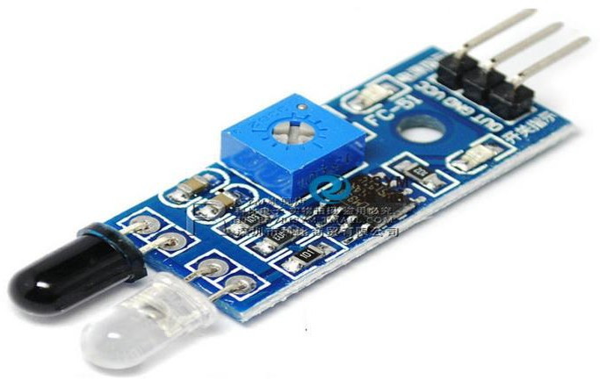

This sensor measure the content of alcohol from the breath of drunken people. If the sensor getting alcoholic content inside our body then it damp down alcoholic. The IR sensor having two main parts one IR transmitter & IR receiver. If the eye is closed then output of IR receiver is low and eye is open then output of IR receiver is high. The function of this two part are vice versa. The IR transmitter transmit infrared rays in our eye and receiver. Receiver this reflected ray of eyes.

## Alcohol Sensor:

**Working Principle:**

Sensitive material of MQ-3 gas sensor is SnO2, which with lower conductivity in clean air. When the target alcohol gas exist, The sensor’s conductivity is more higher along with the gas concentration rising. Please use simple electrocircuit, Convert change of conductivity to correspond output signal of gas concentration. MQ-3 gas sensor has high sensitity to Alcohol, and has good resistance to disturb of gasoline, smoke and vapor.

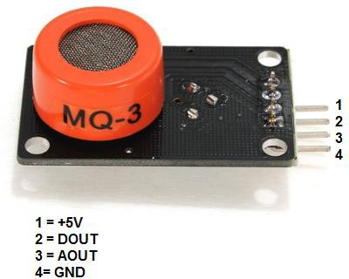

An alcohol sensor detects the attentiveness of alcohol gas in the air and an analog voltage is an output reading. The [sensor can activate at temperatures](https://www.elprocus.com/temperature-sensors-types-working-operation/) ranging from -10 to 50° C with a power supply is less than 150 Ma to 5V. The sensing range is from 0.04 mg/L to 4 mg/L, which is suitable for breathalyzers.

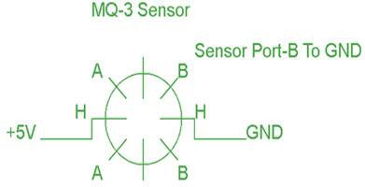

## ULTRASONIC SENSOR-

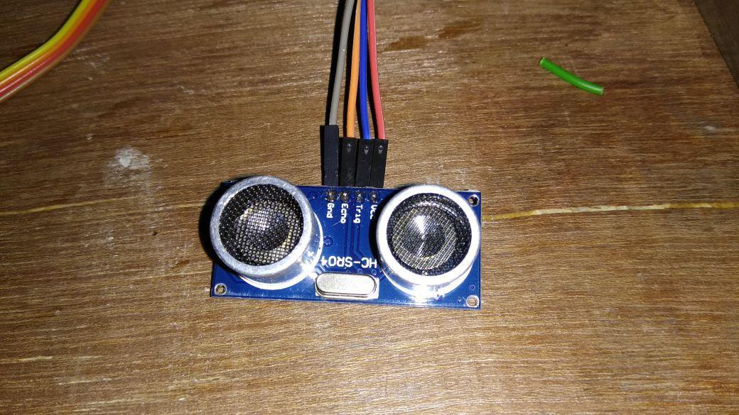

Fig3.8.1 sensor

An Ultrasonic sensor is a device that can measure the distance to an object by using sound waves. It measures distance by sending out a sound wave at a specific frequency and listening for that sound wave to bounce back. By recording the elapsed time between the sound wave being generated and the sound wave bouncing back, it is possible to calculate the distance between the sonar sensor and the object. As the name indicates, ultrasonic sensors measure distance by using ultrasonic waves.The sensor head emits an ultrasonic wave and receives the wave reflected back from the target. Ultrasonic Sensors measure the distance to the target by measuring the time between the emission and reception.An optical sensor has a transmitter and receiver, whereas an ultrasonic sensor uses a single ultrasonic element for both emission and reception. In a reflective model ultrasonic sensor, a single oscillator emits and receives ultrasonic waves alternately. This enables miniaturization of the sensor head.

**HC-SR04 Specifications :**

•Working Voltage: DC 5V

•Working Current: 15mA

•Working Frequency: 40Hz

•Max Range: 4m

•Min Range: 2cm

•Measuring Angle: 15 degree

•Trigger Input Signal: 10µS TTL pulse

•Echo Output Signal Input TTL lever signal and the range in proportion

•Dimension 45 * 20 * 15mm

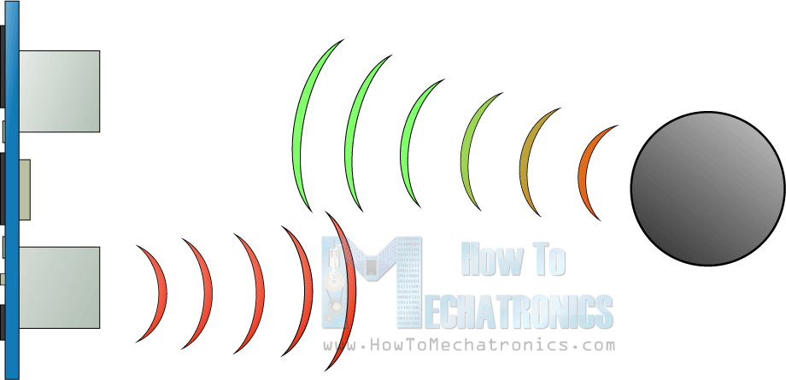

Fig:3.8.2:

The HC-SR04 Ultrasonic Module has 4 pins, Ground, VCC, Trig and Echo. The Ground and the VCC pins of the module needs to be connected to the Ground and the 5 volts pins on the Arduino Board respectively and the trig and echo pins to any Digital I/O pin on the Arduino Board.

In order to generate the ultrasound, you need to set the Trig on a High State for 10 µs. That will send out an 8 cycle sonic burst which will

travel at the speed sound and it will be received in the Echo pin. The Echo pin will output the time in microseconds the sound wave traveled.

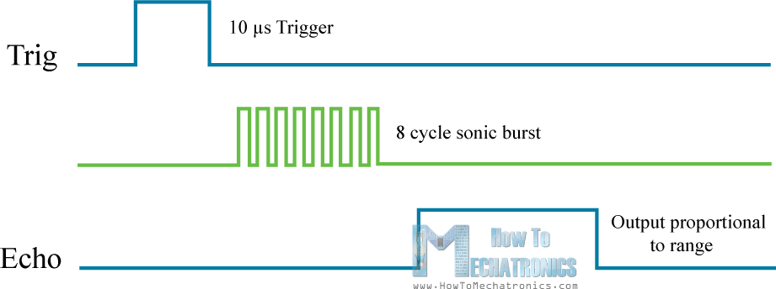

Fig.3.8.3 Waveforms

For example, if the object is 10 cm away from the sensor, and the speed of the sound is 340 m/s or 0.034 cm/µs the sound wave will need to travel about 294 u seconds. But what you will get from the Echo pin will be double that number because the sound wave needs to travel forward and bounce backward. So in order to get the distance in cm we need to multiply the received travel time value from the echo pin by 0.034 and divide it by 2.

## GPS:

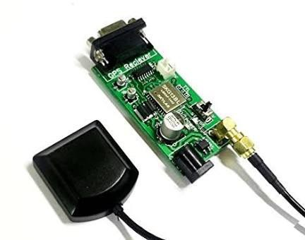

Fig 3.9.1: GPS Module





The GPS concept is based on time and the known position of GPS specialized [satellites](https://en.wikipedia.org/wiki/Satellite). The satellites carry very stable [atomic clocks](https://en.wikipedia.org/wiki/Atomic_clocks) that are synchronized with one another and with the ground clocks. Any drift from true time maintained on the ground is corrected daily. In the same manner, the satellite locations are known with great precision. GPS receivers have clocks as well, but they are less stable and less precise.

GPS satellites continuously transmit data about their current time and position. A GPS receiver monitors multiple satellites and solves equations to determine the precise position of the receiver and its deviation from true time. At a minimum, four satellites must be in view of the receiver for it to compute four unknown quantities (three position coordinates and clock deviation from satellite time)



* Navigation: Soldiers use GPS to find objectives, even in the dark or in unfamiliar

territory, and to coordinate troop and supply movement. In the United States armed forces, commanders use the Commander's Digital Assistant and lower ranks use the Soldier Digital Assistant.

* Target tracking: Various military weapons systems use GPS to track potential ground and air targets before flagging them as hostile. These weapon systems pass target coordinates to [precision-guided munitions](https://en.wikipedia.org/wiki/Precision-guided_munition) to allow them to engage targets accurately. Military aircraft, particularly in [air-to-ground](https://en.wikipedia.org/wiki/Air-to-ground) roles, use GPS to find targets.
* GPS satellites carry a set of nuclear detonation detectors consisting of an optical sensor called a [bhangmeter,](https://en.wikipedia.org/wiki/Bhangmeter) an X-ray sensor, a dosimeter, and an electromagnetic pulse (EMP) sensor (W-sensor), that form a major portion of the [United States Nuclear Detonation](https://en.wikipedia.org/wiki/United_States_Nuclear_Detonation_Detection_System) [Detection System](https://en.wikipedia.org/wiki/United_States_Nuclear_Detonation_Detection_System).General William Shelton has stated that future satellites may drop this feature to save money.[[98]](https://en.wikipedia.org/wiki/Global_Positioning_System#cite_note-98)

GPS type navigation was first used in war in the [1991 Persian Gulf War](https://en.wikipedia.org/wiki/Gulf_War), before GPS was fully developed in 1995, to assist [Coalition Forces](https://en.wikipedia.org/wiki/Coalition_of_the_Gulf_War) to navigate and perform maneuvers in the war. The war also demonstrated the vulnerability of GPS to being [jammed](https://en.wikipedia.org/wiki/Radio_jamming), when Iraqi forces installed jamming devices on likely targets that emitted radio noise, disrupting reception of the weak GPS signal.

## GSM:

GSM stands for Global System for Mobile communication. Today, GSM is used by more than 800 million end users spread across 190 countries which represents around 70 percent of today’s digital wireless market.

In GSM, geographical area is divided into hexagonal cells whose side depends upon power of transmitter and load on transmitter (number of end user). At the center of cell, there is a base station consisting of a transceiver (combination of transmitter and receiver) and an antenna.

**Function of Components:**

Mobile station (MS): It refers for mobile station. Simply, it means a mobile phone. Base transreceiver system (BTS): It maintains the radio component with MS.

Base station controller (BSC): Its function is to allocate necessary time slots between the BTS and MSC.

Home location register (HLR): It is the reference database for subscriber parameter like subscriber’s ID, location, authentication key etc.

Vistor location register (VLR): It contains copy of most of the data stored in HLR which is temporary and exist only until subscriber is active.

Equipment identity register (EIR): It is a database which contains a list of valid mobile equipment on the network.

Authentication center (AuC): It perform authentication of subscriber.

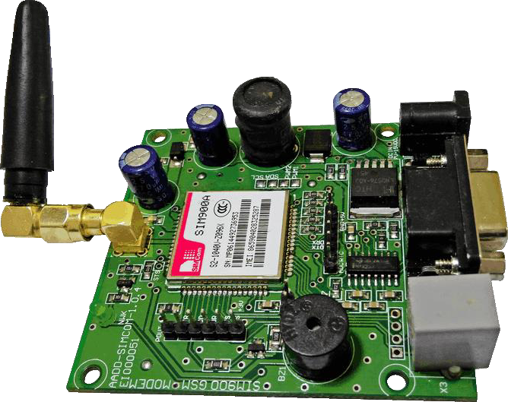

**Fig. 3.8.1 GSM**

* + 1. **Specifications of GSM**

|  |  |  |
| --- | --- | --- |
| **1.** | **Working**  **frequencies** | **GSM 850MHz, EGSM 900MHz, DCS 1800MHz**  **and PCS 1900MHz** |
| **2.** | **Power supply** | **External power supply of ~12V** |
| **3.** | **Current** | **Draw up to ~2A of current at its peak.** |

**GSM**

The **SIM900A** is a readily available **GSM/GPRS module**,used in many mobile phones and PDA. The module can also be used for developing IOT (Internet of Things) and Embedded Applications. SIM900A is a dual-band GSM/GPRS engine that works on frequencies EGSM 900MHz and DCS 1800MHz. SIM900A features GPRS multi-slot class 10/ class 8 (optional) and supports the GPRS coding schemes CS-1, CS-2, CS-3 and CS-4.

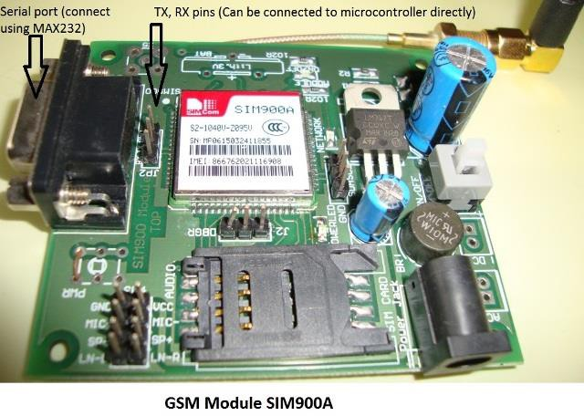

SIM900A GSM MODULE Features

* Single supply voltage: 3.4V – 4.5V
* Power saving mode: Typical power consumption in SLEEP mode is 1.5mA
* Frequency bands:SIM900A Dual-band: EGSM900, DCS1800. The SIM900A can search the two frequency bands automatically. The frequency bands also can be set by AT command.
* GSM class: Small MS
* GPRS connectivity:GPRS multi-slot class 10 (default) , GPRS multi-slot class 8 (option)
* Transmitting power: Class 4 (2W) at EGSM 900, Class 1 (1W) at DCS 1800
* Operating Temperature: -30ºC to +80ºC
* Storage Temperature: -5ºC to +90ºC
* DATA GPRS: download transfer max is 85.6KBps, Upload transfer max 42.8KBps
* Supports CSD, USSD, SMS, FAX
* Supports MIC and Audio Input
* Speaker Input
* Features keypad interface
* Features display interface
* Features Real Time Clock
* Supports UART interface
* Supports single SIM card
* Firmware upgrade by debug port
* Communication by using AT commands

It communication with this module is done through UART or RS232 Interface. The data is sent to the module or received from the module though UART interface.

The module is typically connected to +4.0V standard power supply. It can work on

+4.5V regulated power and any higher voltage may damage the module. And the power source should be able to deliver a peak current of 2A. The UART interface is established as shown in figure.

|  |  |  |
| --- | --- | --- |
| **Pin Number** | **Pin Name** | **Description** |
| 1 | PWRKEY | Voltage input for PWRKEY. PWRKEY should be pulled low to power on or power off the system.The user should keep pressing the key for a short time when power on or power off the system because the system need margin time in order to assert the software. |
| 2 | PWRKEY_ OUT | Connecting PWRKEY and PWRKEY_OUT for a short time then release also can power on or power off the module. |
| 3 | DTR | Data terminal Ready [Serial port ] |
| 4 | RI | Ring indicator [Serial port ] |
| 5 | DCD | Data carry detect [Serial port ] |
| 6 | DSR | Data Set Ready [Serial port ] |
| 7 | CTS | Clear to send [Serial port ] |
| 8 | RTS | Request to send [Serial port ] |
| 9 | TXD | Transmit data [Serial port ] |
| 10 | RXD | Receive data [Serial port ] |
| 11 | DISP  _CLK | Clock for display [Display interface] |
| 12 | DISP_DAT A | Display data output [Display interface] |
| 13 | DISP _D/C | Display data or command select [Display interface] |
| 14 | DISP _CS | Display Enable [Display interface] |
| 15 | VDD_EXT | 2.8V output power supply |
| 16 | NRESET | External reset input |

**Advanced Safety Technologies in Automobile Sector**

|  |  |  |
| --- | --- | --- |
| 17,18,29,39  ,45,  46,53,54,58  ,59,  61,62,63,64  ,65 | GND | Ground |
| 19 | MIC_P | Microphone Positive |
| 20 | MIC_N | Microphone Negative |
| 21 | SPK_P | Speaker Positive |
| 22 | SPK_N | Speaker Negative |
| 23 | LINEIN_R | Right Channel input [External line inputs are available to directly mix or multiplex externally generated analog signals such as polyphonic tones from an external melody IC or music generated by an FM tuner IC or module.] |
| 24 | LINEIN_L | Left Channel Input |
| 25 | ADC | General purpose analog to digital converter. |
| 26 | VRTC | Current input for RTC when the battery is not supplied for the system.  Current output for backup battery when the main battery is present and the backup battery is in low voltage state. |
| 27 | DBG_TXD | Transmit pin [Serial interface for debugging and firmware upgrade ] |
| 28 | DBG_RXD | Receive pin [Serial interface for debugging and firmware upgrade ] |
| 30 | SIM_VDD | Voltage supply for SIM card |
| 31 | SIM_DAT A | SIM data output |

|  |  |  |
| --- | --- | --- |
| 32 | SIM_CLK | SIM clock |
| 33 | SIM_RST | SIM reset |
| 34 | SIM_PRES ENCE | SIM detect |
| 35 | PWM1 | PWM Output |
| 36 | PWM2 | PWM Output |
| 37 | SDA | Serial Data [I2C] |
| 38 | SCL | Serial Clock [I2C] |
| 40,41,42,43  ,44  & 47,48,49,50  ,51 | KBR0 to KBR4  &  KBC4 to KBC0 | Keypad interface [ROWS & COLUMNS] |
| 52 | NETLIGH T | Indicate net status |
| 55,56,57 | VBAT | Three VBAT pins are dedicated to connect the supply voltage. The power supply of SIM900A has to be a single voltage source of VBAT= 3.4V to 4.5V. It must be able to provide sufficient current in a transmit burst which typically rises to 2A. |
| 60 | RF_ANT | Antenna connection |
| 66 | STATUS | Indicate working status |
| 67 | GPIO 11 | General Purpose Input/output |
| 68 | GPIO 12 | General Purpose Input/output |

Reference. Here AUDIO IN is connected to MIC and AUDIO OUT is connected to a speaker or headset. And at last we need to connect a working GSM SIM card to the module. On powering the module the NETLIGHT LED will blink periodically to state successful connection.

After all connections are done,we need to write a program for the microcontroller to exchange data with module. Since data exchange sequence between controller and module is really complex we will use libraries prewritten for the module. You can download libraries for controller or module through their websites. Using these libraries makes the communication easy. All you need to do is download these libraries and call them in programs. Once the header file is included, you can use simple commands in the program to tell the controller to send or receive data. The controller sendsthe data to the module through UART Interface based on protocol setup in libraries. The module sends this data to another GSM user using cellular network. If the module receives any data from the cellular network (or another GSM user) it will transmit it to controller through UART serial communication.

SIM900A GSM Module Pinout Configuration:

SIM900A is a 68 terminal device as shown in **pin diagram**. We will describe the function of each pin below.

* 1. **LCD**

We always use devices made up of Liquid Crystal Displays (LCDs) like computers, digital watches and also DVD and CD players. They have become very common and have taken a giant leap in the screen industry by clearly replacing the use of Cathode Ray Tubes (CRT). CRT draws more power than LCD and are also bigger and heavier. LCD’s have made displays thinner than CRT’s. Even while comparing the LCD screen to an LED screen, the power consumption is lesser as it works on the basic principle of blocking light rather than dissipating. All of us have seen an LCD, but no one knows the exact working of it. Let us take a look at the working of an LCD.

The main principle behind liquid crystal molecules is that when an electric current is applied to them, they tend to untwist. This causes a change in the light angle passing through them. This causes a change in the angle of the top polarizing filter with respect to it. So little light is allowed to pass through that particular area of LCD. Thus that area becomes darker comparing to others.

For making an LCD screen, a reflective mirror has to be setup in the back. An electrode plane made of indium-tin oxide is kept on top and a glass with a polarizing film is also added on the bottom side. The entire area of the LCD has to be covered by a common electrode and above it should be the liquid crystal substance. Next comes another piece of glass with an electrode in the shape of the rectangle on the bottom and, on top, another polarizing film. It must be noted that both of them are kept at right angles. When there is no current, the light passes through the front of the LCD it will be reflected by the mirror and bounced back. As the electrode is connected to a temporary battery the current from it will cause the liquid crystals between the common-plane electrode and the electrode shaped like a rectangle to untwist. Thus the light is blocked from passing through. Thus that particular rectangular area appears blank.

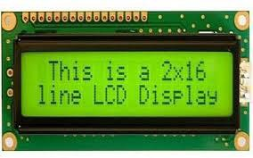

**Fig. 3.9.1 LCD Display**

**Pin Description:**

|  |  |  |
| --- | --- | --- |
| **Sr.No.**  1 | **Function**  Ground | **Name**  Ground |
| 2 | Su(4.7V-5.3V) | VCC |
| 3 | Contrast adjustment; through a variable resistor | VEE |
| 4 | Selects command register when low | RS |
|  | Data register when high |  |
| 5 | Low to write to register; high to read from | R/W |
| 6 | Sends data to data pins when a high to low pulse | Enable |
| 7 | given  8-bit data lines | DB0-DB7 |
| 8 | Backlight VCC(5V) | Led+ |
| 9 | Backlight Ground(0V) | Led- |

* + 1. **Features of LCD display**

|  |  |  |
| --- | --- | --- |
| **1.** | **LCD Display** | **16 character by 2 line display** |
| **2.** | **Operating voltage** | **4.7V to 5.3V** |
| **3.** | **Current consumption** | **1mA without backlight** |
| **4.** | **Pixel box for each**  **character** | **5x8 pixel box** |
| **5.** | **LCD display module** | **Alphanumeric LCD display module, meaning**  **can display alphabets and numbers** |

## Flowchart

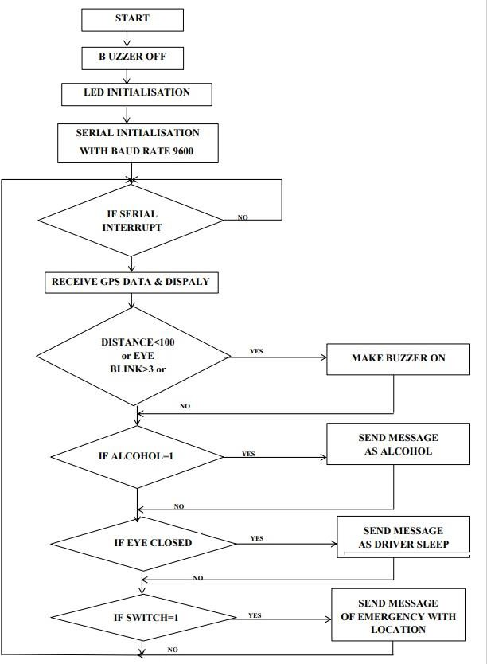

**3.13. Program for the Project**

**#include<stdio.h> #include<reg52x2.h> void lcdini(void);**

**void welcome(void); void cmd(int);**

**void disp(int); void delay(void); void sec(void); void serini(void); void ultra(void); void htob(void); void sms(void); void sms1(void); void sms2(void); void trx(int); void at(void);**

**void at1(void);**

**void at2(void);**

**void at3(void);**

**void at4(void);**

**void at5(void); unsigned ch;**

**int cnt=0,chk=0,i=0,chk1=0,chk2=0,chk3=0; int h1,aa,jjj,ii,eye1=0;**

**unsigned char a[60]; sbit rs=P3^6;**

**sbit en=P3^7; sbit utx=P2^3; sbit urx=P2^4; sbit buz=P2^6; sbit alco=P2^0; sbit limit=P2^5; sbit eye=P2^1;**

**void main()**

**{ buz=1;**

**lcdini(); welcome(); sec();**

**serini();**

**while(1)**

**{ delay(); }**

**}**

**{**

**cmd(0x01); disp('A');**

**disp('T');**

**trx('A');**

**trx('T'); trx(0x0d);**

**trx(0x0a);**

**}**

**void at(void)**

**{**

**cmd(0x38); cmd(0x0c); cmd(0x06); cmd(0x01);**

**}**

**void lcdini(void)**

**void cmd(int i)**

**{**

**//int j;**

**//j=i;**

**P0=i;**

**rs=0; en=1; en=0; delay();**

**}**

**void disp(int i)**

**{**

**//int j;**

**//j=i;**

**P0=i;**

**rs=1; en=1;**

**en=0; delay();**

**}**

**void welcome(void)**

**{**

**disp('W');**

**disp('e');**

**disp('l');**

**disp('c');**

**disp('o');**

**disp('m');**

**disp('e');**

**}**

**void sec()**

**{**

**int j; for(j=0;j<200;j++)**

**{**

**delay();**

**}**

**}**

**void delay(void)**

**{**

**T2MOD=0X00;**

**TH2=0XEF; TL2=0X78; TR2=1;**

**up: if(TF2==1)**

**{**

**TR2=0;**

**TF2=0;**

**}**

**else**

**{**

**goto up;**

**}**

**}**

**void serini()**

**{**

**TMOD=0X25;**

**TH1=0XFD;**

**TL1=0XFD;**

**TR1=1;**

**SCON=0X50; IE=0X90;**

**}**

**void ser() interrupt 4**

**{ ch=SBUF;**

**IE=0X00; TI=0;**

**// disp(ch);**

**if(RI)**

**{**

**if(ch=='C')**

**{**

**chk=1; cnt=0;**

**}**

**else if((chk==1) && (ch=='*'))**

**{**

**cmd(0x01);**

**cmd(0x80); for(i=14;i<23;i++)**

**{**

**disp(a[i]);**

**}**

**cmd(0xc0); for(i=27;i<36;i++)**

**{**

**disp(a[i]);**

**}**

**sec();**

**ultra();**

**htob();**

**if((aa<100) | (alco==0) | (eye1>3))**

**{**

**}**

**else**

**{**

**}**

**buz=0;**

**buz=1;**

**if((alco==0) & (chk1==0))**

**{**

**sms(); chk1=1;**

**}**

**else**

**{**

**}**

**chk1=0;**

**if((limit==0) & (chk2==0))**

**{**

**}**

**else**

**{**

**}**

**sms1(); chk2=1;**

**chk2=0;**

**if(eye==0)**

**{**

**eye1=eye1+1;**

**}**

**else**

**{**

**}**

**eye1=0;**

**if((eye1>3) & (chk3==0))**

**{**

**}**

**else**

**{**

**}**

**chk=0; cnt=0;**

**sms2(); chk3=1;**

**chk3=0;**

**}**

**else if((chk==1) && (ch!='*'))**

**{**

**a[cnt]=ch; cnt=cnt+1;**

**}**

**}**

**RI=0;**

**TR2=1;**

**IE=0X90;**

**}**

**void ultra()**

**{**

**delay(); utx=1;**

**//disp('c'); for(ii=0;ii<10;ii++)**

**{}**

**jjj=0; utx=0;**

**while(urx==0);**

**upk: if(urx==1)**

**{**

**jjj=jjj+1; if(jjj<4000)**

**{**

**goto upk;**

**}**

**}**

**else**

**{**

**h1=jjj; aa=h1;**

**}**

**}**

**void htob()**

**{**

**disp('D');**

**disp(':');**

**aa=aa*3; disp((aa/10000)+0x30); disp(((aa%10000)/1000)+0x30); disp((((aa%10000)%1000)/100)+0x30);**

**disp(((((aa%10000)%1000)%100)/10)+0x30); disp(((((aa%10000)%1000)%100)%10)+0x30);**

**}**

**void sms()**

**{**

**at();**

**sec();**

**at1();**

**at2();**

**at3();**

**}**

**void sms1()**

**{**

**at();**

**sec();**

**}**

**at1();**

**at2();**

**at4();**

**void sms2()**

**{**

**sec();**

**}**

**at();**

**at1();**

**at2();**

**at5();**

**void at1(void)**

**{**

**cmd(0x01); disp('A');**

**disp('T');**

**disp('+');**

**disp('C');**

**disp('M');**

**disp('G');**

**disp('F');**

**disp('=');**

**disp('1');**

**trx('A');**

**trx('T');**

**trx('+');**

**trx('C');**

**trx('M');**

**trx('G');**

**trx('F');**

**trx('=');**

**trx('1');**

**trx(0x0d);**

**trx(0x0a);**

**sec();**

**}**

**void at2(void)**

**{**

**cmd(0x01); disp('A');**

**disp('T');**

**disp('+');**

**disp('C');**

**disp('M');**

**disp('G');**

**disp('S');**

**disp('='); cmd(0xc0);**

**disp('8');**

**disp('9');**

**disp('2');**

**disp('8');**

**disp('6');**

**disp('0');**

**disp('8');**

**disp('6');**

**disp('1');**

**disp('5');**

**trx('A');**

**trx('T');**

**trx('+');**

**trx('C');**

**trx('M');**

**trx('G');**

**trx('S');**

**trx('=');**

**trx('"');**

**trx('8');**

**trx('9');**

**trx('2');**

**trx('8');**

**trx('6');**

**//9881649429**

**//9881649429**

**trx('0');**

**trx('8');**

**trx('6');**

**trx('1');**

**trx('5');**

**trx('"');**

**trx(0x0d);**

**trx(0x0a);**

**sec();**

**}**

**void at4()**

**{**

**trx('E');**

**trx('m');**

**trx('e');**

**trx('r');**

**trx('g');**

**trx('e');**

**trx('n');**

**trx('c');**

**trx('y'); trx(0x0d);**

**trx(0x0a); trx('L');**

**trx('o');**

**trx('n');**

**trx(':'); for(i=14;i<23;i++)**

**{**

**trx(a[i]);**

**}**

**trx(0x0d);**

**trx(0x0a); trx('L');**

**trx('a');**

**trx('t');**

**trx(':'); for(i=27;i<36;i++)**

**{**

**trx(a[i]);**

**}**

**trx(0x1a);**

**cmd(0x01); disp('E');**

**disp('m');**

**disp('e');**

**disp('r');**

**disp('g');**

**disp('e');**

**disp('n');**

**disp('c');**

**disp('y'); sec();**

**}**

**void at3()**

**{**

**trx('A');**

**trx('l');**

**trx('c');**

**trx('o');**

**trx('h');**

**trx('o');**

**trx('l');**

**trx(' ');**

**trx('D');**

**trx('e');**

**trx('t');**

**trx('e');**

**trx('c');**

**trx('e');**

**trx('d');**

**trx(0x1a); cmd(0x01); disp('A');**

**disp('l');**

**disp('c');**

**disp('o');**

**disp('h');**

**disp('o');**

**disp('l');**

**sec();**

**}**

**void at5()**

**{**

**trx('D');**

**trx('r');**

**trx('i');**

**trx('v');**

**trx('e');**

**trx('r');**

**trx(' ');**

**trx('s');**

**trx('l');**

**trx('e');**

**trx('e');**

**trx('p');**

**trx('i');**

**trx('n');**

**trx('g');**

**trx(0x1a); cmd(0x01); disp('S');**

**disp('l');**

**disp('e');**

**disp('e');**

**disp('p'); sec();**

**}**

**void trx(int s)**

**{**

**SBUF=s;**

**while(TI==0);**

**TI=0;**

**}**

## Photo of Project:

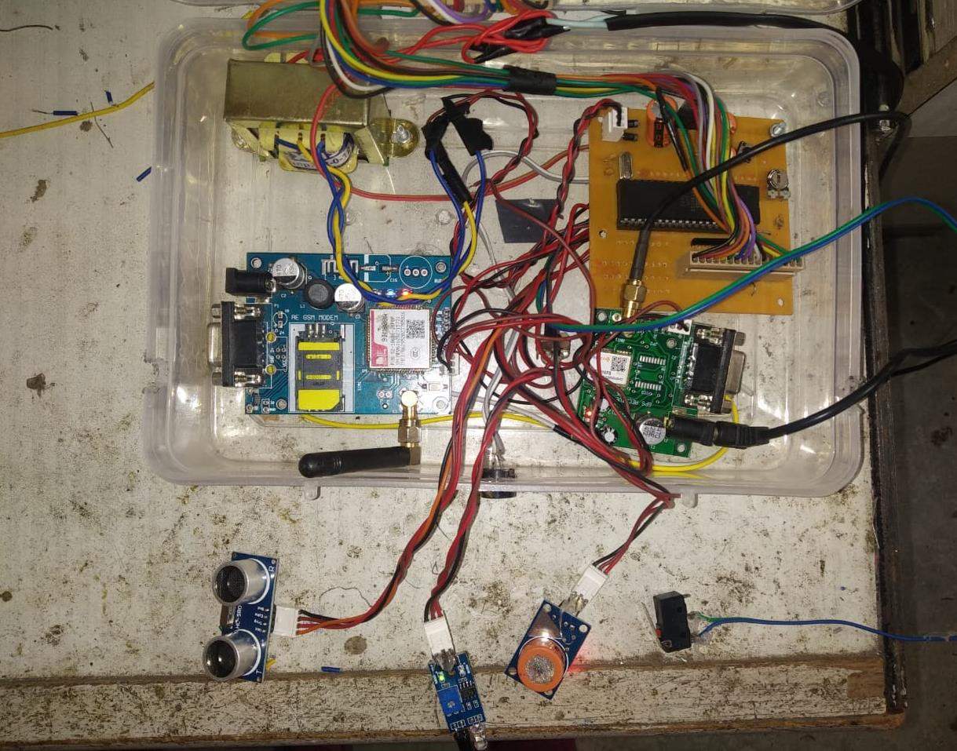

* 1. **Output readings of mobile user:**

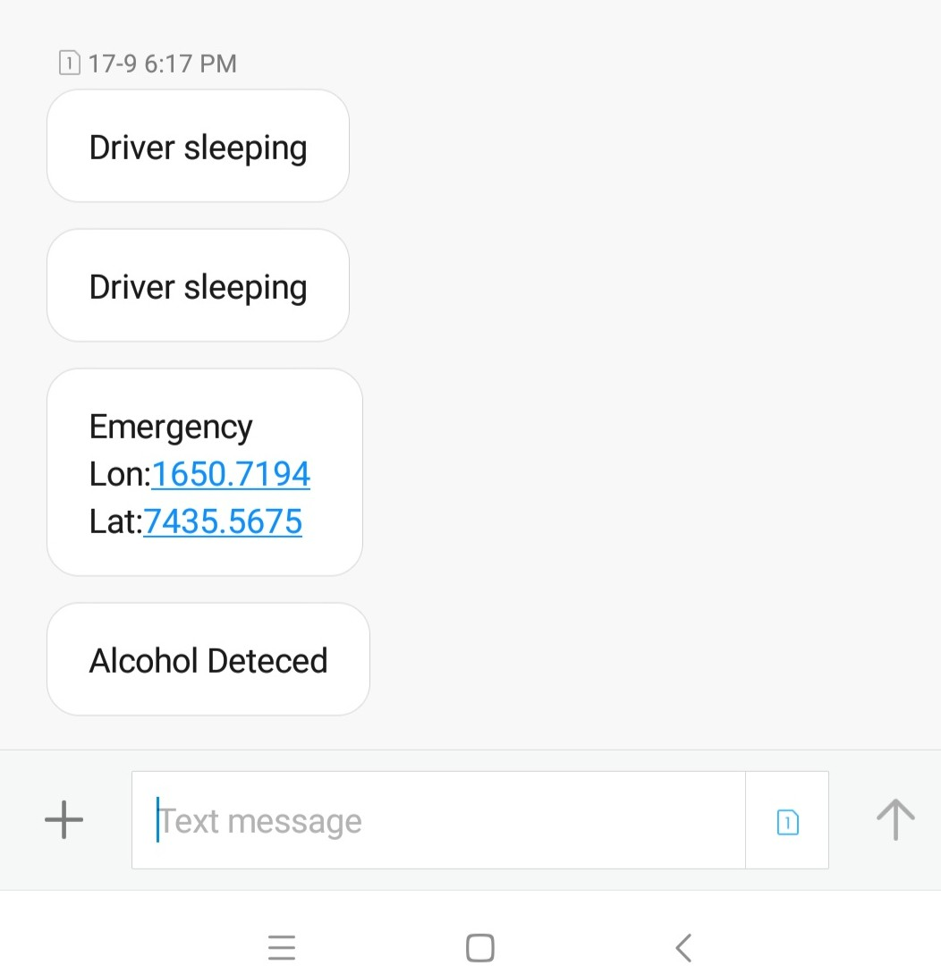

Chapter 4

# Conclusion & Future Scope

### CONCLUSION

After completing our initial research compiling a list of all automobile safety technologies, we needed to select a few key safety technologies to cover in depth. To do this a campus-wide survey was conducted to determine which safety devices would be the most valuable to cover. By taking the results of this survey into account we selected five key groups of safety technologies.

We then thoroughly researched the purpose, history, & functionality of these devices. Once we gathered and processed this information we were ready to start creating content for our presentations, writing scripts and finding content to go along with them. The completion of our background research phase was crucial to defining our project and allowing us to move forward in meeting our goals.

### FUTURE SCOPE

One of the major areas in which this project could be improved is reducing its size. While its final size was significantly smaller than the original designs size, it is still too large to easily transport. If we were to repeat this project we would design it such that it could fit in a standard automobile and sit on a tabletop instead of having its own stand.

This project has the potential to be used in a variety of other venues. After its residency in the WPI library, we hope to find a new home for it at another school, library, or museum. Based on our usage data it has shown itself to be popular amongst WPI students and we think it would be successful with many different age groups. The combination of the educational presentations and supporting tactile hardware make it compelling for people of all ages.

.

Chapter 5

# References

* + - Australian Transport Council: National Road Safety Strategy 2011–2020. Available online: https://roadsafety(accessed on 13 January 2019).
    - 1.S. Al-Youif, M. A. M. Ali and M. N. Mohammed, "Alcohol detection for car locking system," *2018 IEEE Symposium on Computer Applications & Industrial Electronics (ISCAIE)*, Penang, 2018, pp. 230-233.

doi: 10.1109/ISCAIE.2018.8405475

* + - Altaf SV, Abhinay S, Ansari E, Kaunain Md, Anwer R. Alcohol Detection and Motor Locking System. International Journal of Advanced Research in Electrical, Electronics and Instrumentation Engineerng. 2017; 6(2): 989-993.
    - C. Sharmila and Vibin Mammen Vinod, "Design of a real-time tyre pressure monitoring system for LMVs," *2016 Online International Conference on Green Engineering and Technologies (IC-GET)*, Coimbatore, 2016, pp. 1-4. doi: 10.1109/GET.2016.7916790
    - Wiezbicki,T.,Recke.L.,Abramowicz.W.,Gholami.T.,J.Huang.Stress Profiles in Thin- Walled Prismatic Columns Subjected to Crush Loading- 11.Bending,Computers&Structures Vol.51No.6,P625-64 1.
    - National Center for Statistics and Analysis. Passenger vehicles: 2014 data (Traffic safety facts), DOT HS 812 302 [R]. Washington, DC: National Highway Traffic Safety Administration, 2016
    - SUN Yueting, XU Xiaoqing, XU Chengliang, et al. Elastomeric cellular structure enhanced by compressible liquid filler [J]. Sci Rep, 2016, 6: 26694.
    - SHI Xiangnan, CAO Libo, Reed M P, et al. Effects of obesity on occupant responses in frontal crashes: a simulation analysis using human body models [J].Compute Methods Biotech Biomed Eng., 2015, 18: 1280-1296
    - National Center for Statistics and Analysis. Lives saved in 2014 by restraint use and minimum-drinking-age laws, DOT HS 812 218 [R]. Washington, DC: National Highway Traffic Safety Administration, 2015.